|  |  |  |
| --- | --- | --- |
|  | **Sri Lanka Institute of Information Technology**   |  | | --- | | **TMP-22-157** | |

Project Topic Assessment – 2022 (Regular)

|  |
| --- |
| E-Ketha : Enriching rice farmer’s quality of life through a mobile application |

Topic

Abstract (200 Words Max):

|  |
| --- |
| In our country of Sri Lanka, rice is the most common type of food that is consumed daily. Due to that rice farmers face a huge amount of stress to supply according to the massive demand. This is happening while they are farming in poor conditions such as, amongst diseases and pests that harm rice crops with the inclusion of weeds that plague the field. They also have difficulties finding the correct fertilizers and the amount that are needed for the crops to grow properly. Another issue discovered, was that there some rice plants are underdeveloped, and farmers lack the understanding about proper treatment. These topics were chosen according to multitude of statistics including losses due to all insects, losses due to all diseases, losses due to all weeds, potential production harvested, and total potential production lost before harvest being found respectively at 34.4%, 9.9%, 10.8%, 44.9% and 55.1%. The aim is to develop a mobile application that will help farmers solve these problems. The application will use image processing to analyze crops to find solutions stored at a cloud database. Then after machine learning and deep learning will be used to recommend appropriate solutions.      Keywords :- machine learning, image processing, deep learning |

Research Group/Area: Select the area by referring to the document uploaded to the Course Web

Machine Learning and Soft Computing (MLSC)

**Machine Learning (ML)**

**Supervisor should fill this part**

Continuation of Previous Year Project? ☐

Supervisor and Co-Supervisor endorse the proposed project, and hence, guide the students to acquire required knowledge skills pertaining to above sub domains of their specializations.

Supervisor: **Mr. Adeepa Gunarathna** **Select Supervisor**

If yes, state the Project ID

and year

Co-Supervisor: **Ms. Amali Upeka Gunasinghe** **Select Co-Supervisor**

Signature

External Supervisor

Name

Team Members:

|  |  |  |
| --- | --- | --- |
| Student Name | Student ID | Specialization |
| Leader: Salika Madhushanka W.J | IT19101620 | SE |
| Member 2: H.H.W.M.Binuka sihan Paranagama | IT19129372 | SE |
| Member 3: P.Y.D Jayasinghe | IT19117256 | SE |
| Member 4: K.M.Umesh Ranthilina | IT19240152 | SE |

Research Problem:

|  |
| --- |
| Several concerns were found that negatively affect the farmers and the rice crops that reduce the productivity along with profit.   * The first major issue when it comes to paddy is the prevalence of diseases that are native to rice. With new diseases and sicknesses being found each passing day, it becomes difficult for the common farmer to identify and treat them. What is closely related to diseases are pests and other unwanted insects that are also attracted to the crops. These pests might be the reason that diseases are created from the plant in the first place, as well as the reason why diseases are distributed. Pests, even while not spreading disease, might make the crops unsanitary for human consumption [1,5,6]. * The second issue is the growth of unwanted weeds that are prevalent in paddy fields. While weeds do not directly harm rice crops, weeds absorb nutrients from the paddy fields that should have gone for the development of healthy rice plants. The identification of weeds however is not difficult for the common farmer, but the true challenge lies in the recognition of proper weedicide to combat the identified weed. This is due to vast amount of weed types and the equally wide variety of weedicides being difficult to recollect for the common famer [2]. * The next issue is the recognition of suitable fertilizers that are needed for the crops to grow healthy and abundant. Farmers due to lack proper guidance tent to use incorrect fertilizers, fertilizers that have considerable side effects or even the correct fertilizers in wrong amounts thus making it harmful. This has become a major problem in Sri Lanka today due there being reports of various health concerns for the consumer such as increasing the risk of Alzheimer’s disease and Diabetes. The environment is also damaged as a repercussion, examples being contaminated waterways and the destruction of algae. [3]. * Finally, there have been concerns about the fact that, farmers are lacking in knowledge when it comes to the lifecycle of rice crops and whether the rice plant is in the proper phase of the lifecycle at the given time. This can cause mistreatment or no treatment altogether thus resulting poor harvest and there by profit. [4,7]. |

|  |
| --- |
| References   [1]Rahman, C., Arko, P., Ali, M., Iqbal Khan, M., Apon, S., Nowrin, F. and Wasif, A., 2021. Identification and recognition of rice diseases and pests using convolutional neural networks. [online] Available at: <https://www.sciencedirect.com/science/article/abs/pii/S1537511020300830> [Accessed 01 December 2021].  [2]Wang, A., Zhang, W. and Wei, X., 2021. A review on weed detection using ground-based machine vision and image processing techniques. [online] Available at: <https://www.sciencedirect.com/science/article/abs/pii/S0168169918317150> [Accessed 15 December 2021].  [3]Xu, X., He, P., Yang, F., Ma, J., Pampolino, M., Johnston, A. and Zhou, W., 2021. Methodology of fertilizer recommendation based on yield response and agronomic efficiency for rice in China. [online] Available at: <https://www.sciencedirect.com/science/article/abs/pii/S0378429017302861> [Accessed 15 December 2021].  [4]Albizua, A., Bennett, E., Pascual, U. and Larocque, G., 2021. The role of the social network structure on the spread of intensive agriculture: an example from Navarre, Spain.[online] Available at: <https://link.springer.com/article/10.1007/s10113-020-01676-9> [Accessed 18 December 2021].  [5]Ieeexplore.ieee.org. 2021. Detection of Rice Leaf Diseases Using Image Processing. [online] Available at: <https://ieeexplore.ieee.org/abstract/document/9076527> [Accessed 02 December 2021].  [6]Sethy, P., Barpanda, N., Rath, A. and Behera, S., 2021. Image Processing Techniques for Diagnosing Rice Plant Disease: A Survey. [online] Available at: <https://ieeexplore.ieee.org/abstract/document/9076527> [Accessed 02 December 2021].  [7]Ieeexplore.ieee.org. 2021. Information Extraction from Social Network for Agro-produce Marketing. [online] Available at: <https://ieeexplore.ieee.org/abstract/document/6200774> [Accessed 25 December 2021]. |

Solution proposed:

|  |
| --- |
| In order to overcome the research problems above mentioned, a mobile application was proposed that mainly uses image processing and machine learning.   * For the issue of diseases and pests, the application will be using its mobile host’s camera to take a picture of the afflicted rice crops. This picture could be either diseased rice crops, pests or the rice crops harmed by pests. Then this picture or pictures will be analyzed using advanced image processing to identify the prosecutor using the crop’s type, shape and color. After finding the root cause, advanced machine leaning algorithms will be used to give the most suitable solution to handle the diseased rice crops or to remove the type of pests. * For the second issue, application will use the phone’s camera to capture images of the unwanted weeds and pinpoint the type they belong to. The image processing will consider the height, length, shape, color, etc.. for it to be taken in by the machine learning algorithm so as to discover the most fitting fix. This will enable the farmer to remove the weed without the affecting the rice crops. * For the third issue, the camera of the farmer’s cellular phone will be taking a photograph of the rice crops in the paddy field as well as the fertilizer. The image processing will then do its task of calculating the area of the paddy field and the identification of the fertilizer. When the area and type is known, the machine learning will be suggesting the fertilizer’s proper amount and other necessary information including the guidance and the ingredients, so as to not negatively impact the environment or living creatures. * For the final issue, the application will have the capability to measure the rice crop so as to identify the current lifecycle phase. This of cause will be done by the use of mobile camera and image processing technology. Before doing this farmer will have to input the type of the rice crop as well as the date it was planted. After the phase is discovered, if there is any deficiency, the application will be providing the information regarding the deficiency in addition to the proper treatment through machine learning. |

System Overview Diagram for the solution proposed. Recommended to draw using [draw.io.](https://app.diagrams.net/) Note: This is not an activity/flow (UML) diagram

1. **Man components including the data sources, stakeholders, interaction among the stakeholders, etc.**
2. **Interconnection among the components**
3. **Major SW and HW components**

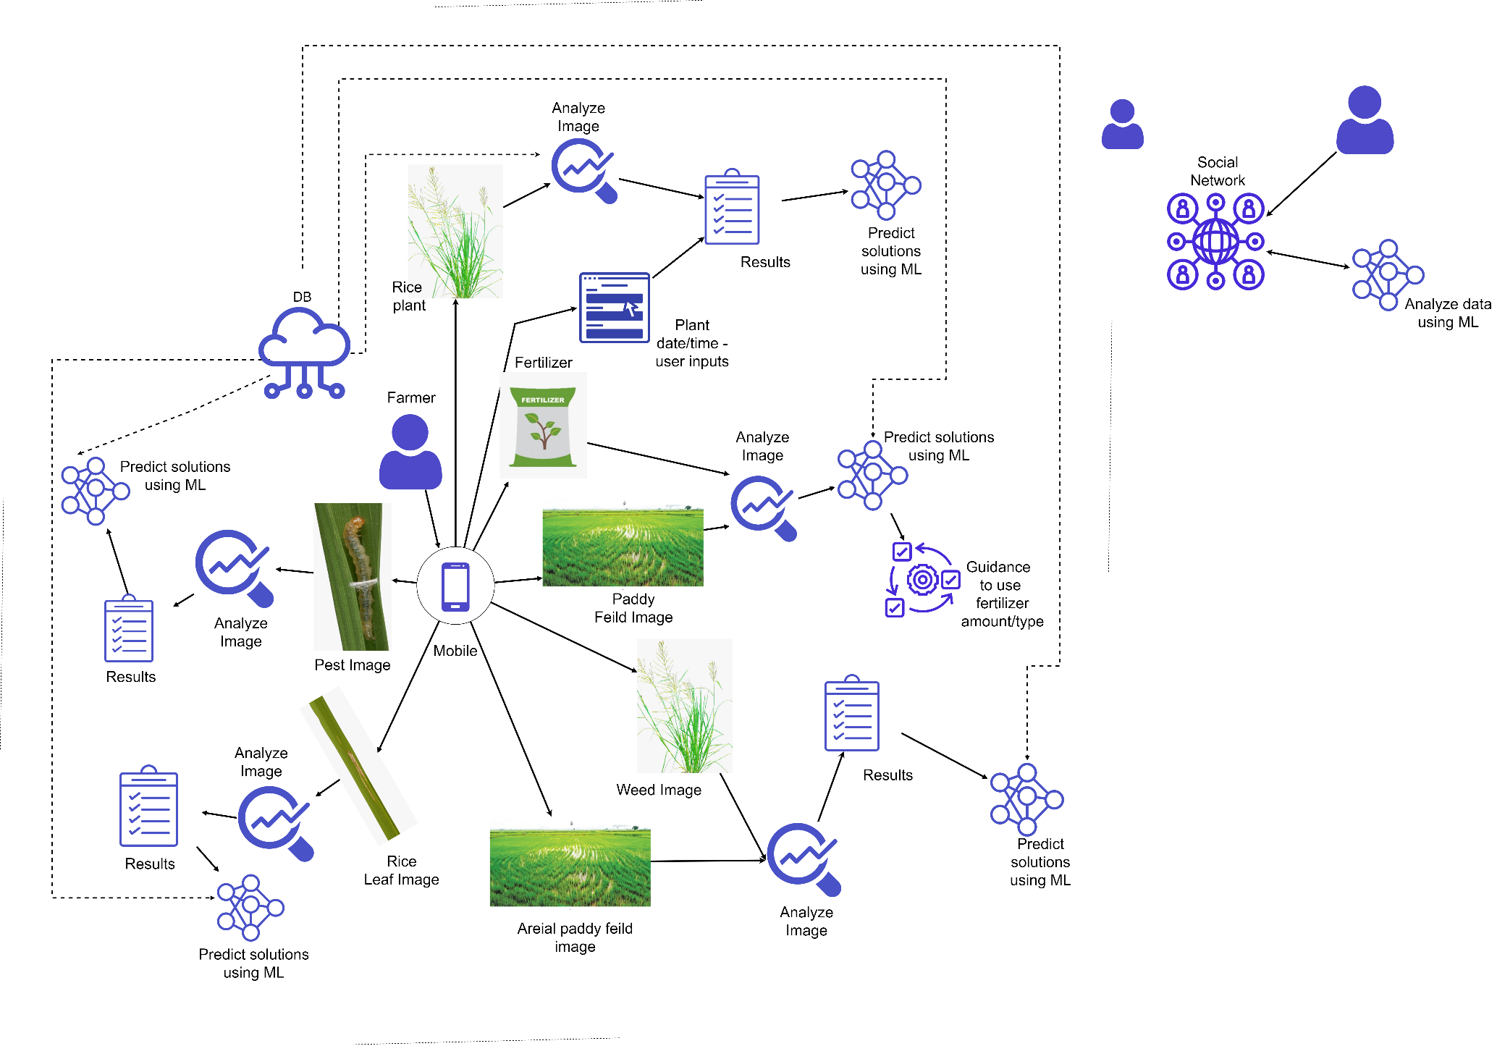

Objectives (1 main objective and 4 sub objectives):

|  |
| --- |
| **Main Objective:**  The main objective of this research project is to help farmers with their paddy fields and make life easier for them. The farmers will be receiving proper guidance and techniques so that producing a steady abundant yield of crops to match the great demand of consumers. Farmers will have the opportunity of exchanging information among one-another so as to regulate knowledge.  **Sub Objective 1:** Detection of pests and diseases using image processing and finding solutions by applying machine learning.  **Sub Objective 2:** Detection of weeds using image processing and finding solutions by applying machine learning.  **Sub Objective 3:** Identification of fertilization information according to the size of paddy field and the fertilizer using image processing, then after providing the instructions by applying machine learning.  **Sub Objective 4:** Rice crop growth identification using image processing and giving solutions to debilitated crops by applying machine learning. |

Task divided among the members

|  |
| --- |
| Member 1  **Detection of pests and diseases using image processing and finding solutions by applying machine learning.**  The first component of the application will be detection of pests and diseases using image processing and finding solutions by applying machine learning. This member is responsible for collecting data and information about various forms of diseases that can trouble rice crops in addition to equally numerous pests that can harm them as well. The data will take the form of images for the use of image processing functionality that will also be implemented by this particular member. After this is completed the application user will have the ability to take a picture of diseased or a pest-ridden crop to identify the type of disease or pest. Then after a machine learning algorithm will be enacted by the member, that will have the capability to present the most suitable solutions to treat the crops. |

|  |
| --- |
| Member 2  **Detection of weeds using image processing and finding solutions by applying machine learning.**  The second component of the application will be detection of weeds using image processing and finding solutions by applying machine learning. This member is responsible for collecting data and information about various breeds of weeds that are inhospitable for rice fields, by sucking up the nutrients from the soil. The data will take the form of images for the use of image processing functionality that will also be implemented by this particular member. After this is completed the application user will have the ability to take a picture of weeds in the paddy field to identify the type. Then after a machine learning algorithm will be enacted by the member, that will have the capability to present the most suitable solutions to remove the weeds without having to harm the rice crops.    Member 3  **Identification of fertilization information according to the size of paddy field and the fertilizer using image processing, then after providing the instructions by applying machine learning.**  The third component of the application will be Identification of fertilization information according to the size of paddy field and the fertilizer using image processing, then after providing the instructions by applying machine learning. This member is responsible for collecting data and information about various kinds of fertilizers that could be applied to various number of fields according to their size. The data will take the form of images for the use of image processing functionality that will also be implemented by this particular member. After this is completed the application user will have the ability to take a picture of rice fields and fertilizers. This will help to identify the best utilization methods with detailed instructions including amount and dosage of fertilization that could be used to aid their growth using the machine learning algorithm enacted by the member. |

|  |
| --- |
| Member 4  **Rice crop growth identification using image processing and giving solutions to debilitated crops by applying machine learning.**  The final component of the application will be the Rice crop growth identification using image processing and giving solutions to debilitated crops by applying machine learning. This member is responsible for collecting data and information about various kinds of rice crops and their respective lifecycles. The data will take the form of images for the use of image processing functionality that will also be implemented by this particular member. After this is completed the application user will first need to input the type and the planted date of the rice plant. Then the user have to take a picture of rice plant. Finally the member has to apply machine learning so as to provide solutions to the deficient crops. |

Technologies to be used:

|  |
| --- |
| Android (Java)  Python  Cloud Database (Azure DB)  Machine Learning  Image Processing |

**Appendix**

Main Supervisor

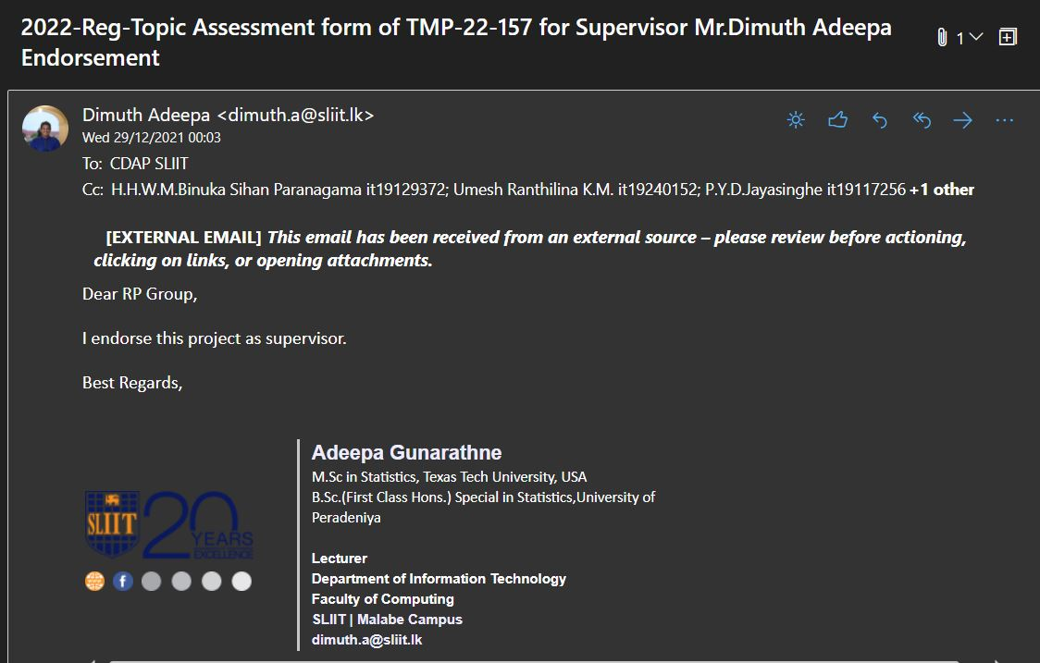

**Co-Supervisor**

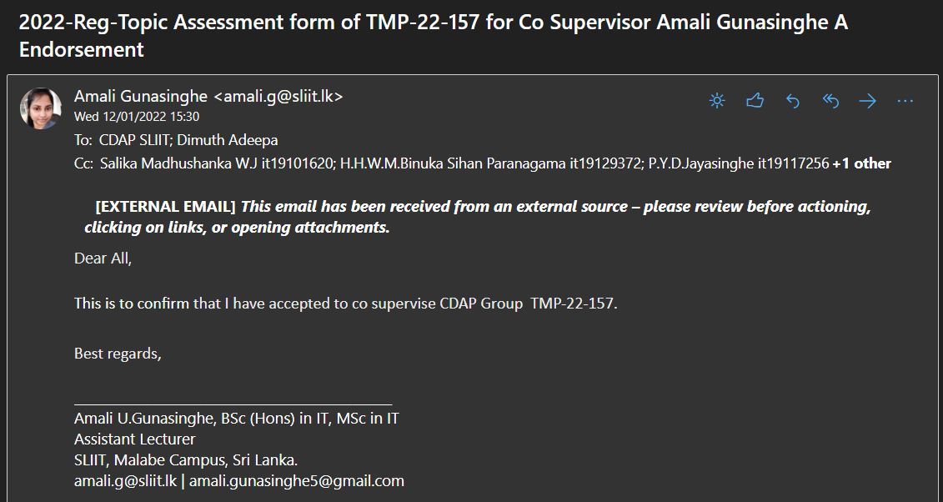

|  |
| --- |
| If supervisor States that this year is a continuation of previous work, state the further work the students should do compared to the previous years.  (NOTE: This part has to be filled by the supervisor) |

|  |
| --- |
|  |

**This part will be filled by the Topic Screening Panel members**

Acceptable: Mark/select as necessary

|  |  |  |
| --- | --- | --- |
| Acceptance/  Rejection | Correction State | |
| Minor Correction | Major Corrections |
| Accepted | ☐ | ☐ |
| Resubmit | ☐ | ☐ |
| Rejected | ☐ | |

**Accepted with Major Corrections**

Corrections (if necessary)

|  |
| --- |
| Sub objectives 01 and 02 are overlapping of research methodologies in image processing. Similarly, Member 01 and Member 02 research contributions are the same and re-adjust them by discussing with your supervisor. Before starting the project check the availability of data set. Highlight the research contribution of member 04 it is not clear. Inputs and outputs of research components of individual member's should be clearly mentioned. |

Major changes proposed:

Sub objectives 01 and 02 are overlapping of research methodologies in image processing. Similarly, Member 01 and Member 02 research contributions are the same and re-adjust them by discussing with your supervisor. Before starting the project check the availability of data set. Highlight the research contribution of member 04 it is not clear. Inputs and outputs of research components of individual member's should be clearly mentioned.

_

Any other Comments: _________________________________________________________________________________________________________________________________________________________________________________________________________________________________

Approved by the review panel:

|  |  |
| --- | --- |
| **Member’s Name** | **Signature** |
| Dr. Darshana Kasthurirathna |  |
| Mr. Udara Samaratunge |  |
|  |  |

**Important**:

1. According to the comments given by the panel, do the necessary modifications and get the approval by the **same panel**.
2. If the project topic is rejected, find out a new topic and inform the CDAP Group for a new topic pre-assessment.
3. A form approved by the panel must be attached to the **Project Charter Form**.